Email: info@marketindia24.com
Phone Number India: +91 800 729 22 54



PRICE LIST

№ | Name of product | FCA price  in USD | Price of DDPMoses in USD | Product photographs
1 | Raisin confectionery | 1.8 | 1.94 | 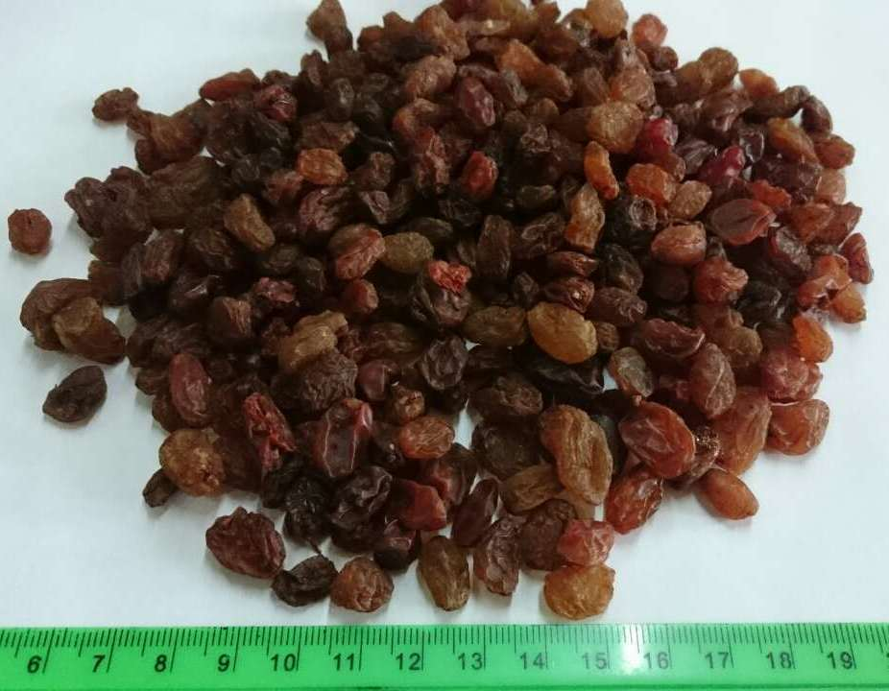
2 | Raisin Kalifar  (Not processed) | 2,48 | 2,61 | 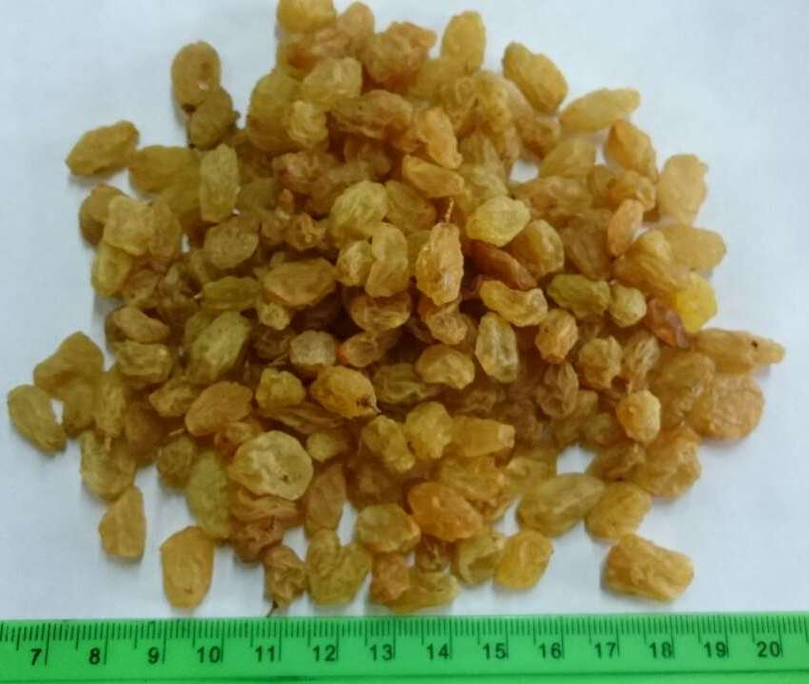
3 | Raisin Kalifar | 2.93 | 3,06 | 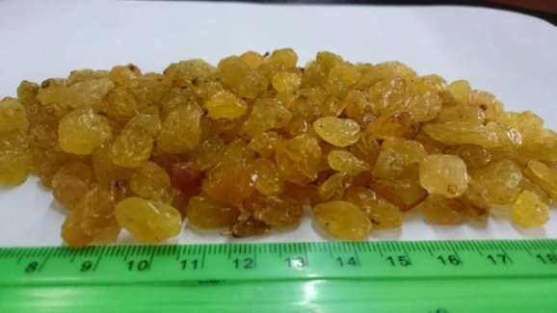
4 | Raisin black confectionery  Kunaki (dried in the sun)  Raisin black  Soyaki (dried in the shade) | 2,34  2.88 | 2,48  3,02 | 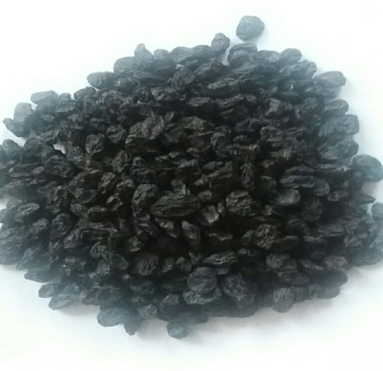
5 | Dried apricots  (First grade) | 2,03 | 2,16 | 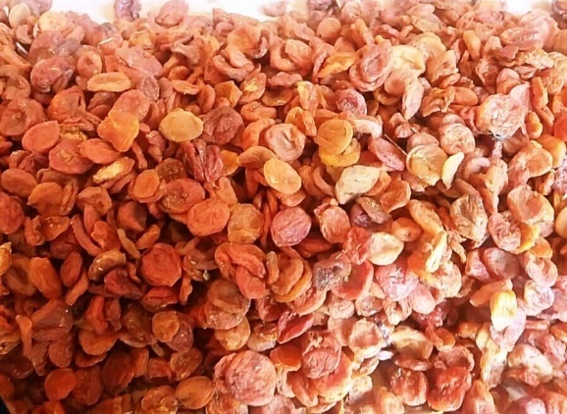
6 | Dried apricots  (Class II) | 1.89 | 2,03 | 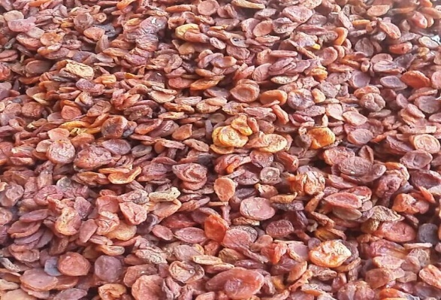
7 | Prunes with stones | 1,76 | 1.89 | 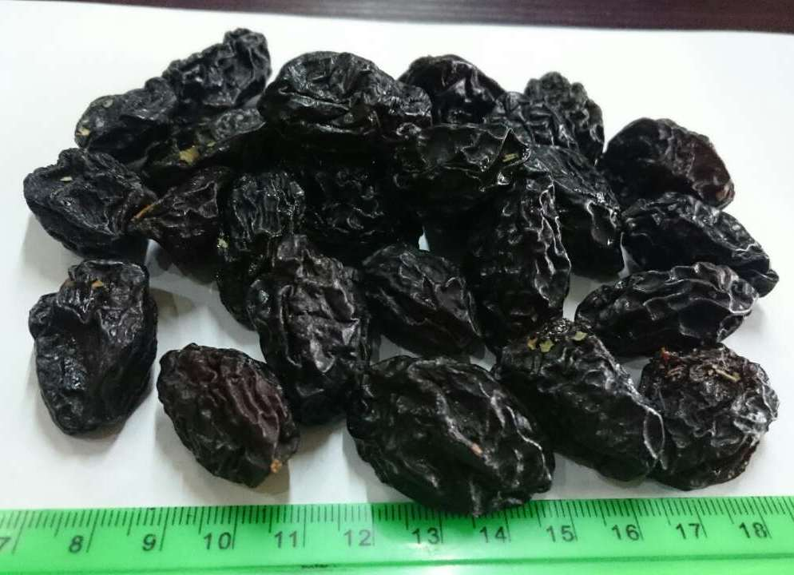
8 | Prunes without stones  (Cans) | 1.94 | 2,07 | 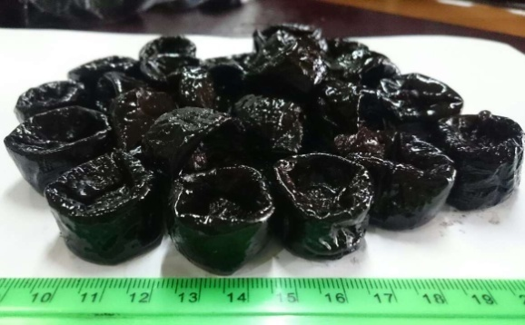
9 | Prunes without stones  (Hungarian) | 2,03 | 2,16 | 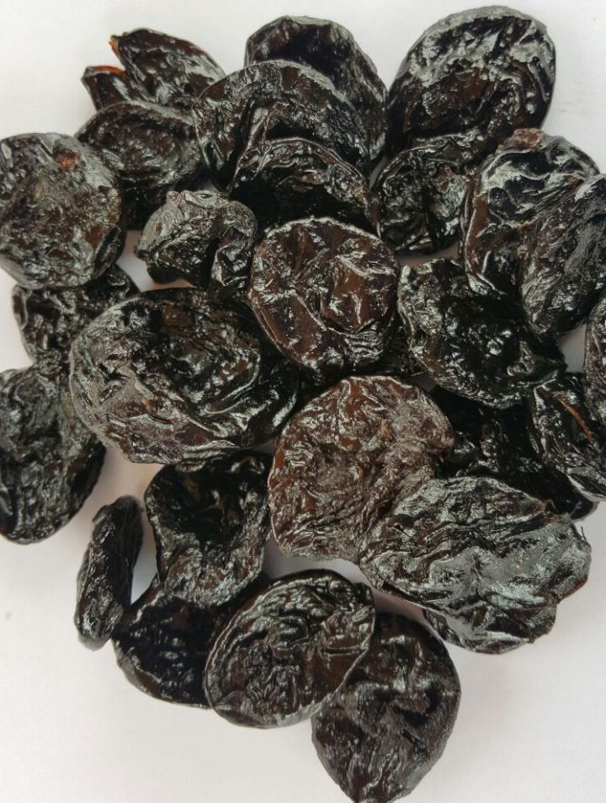
10 | Dry compote mixture  (Top Grade) | 1,08 | 1,22 | 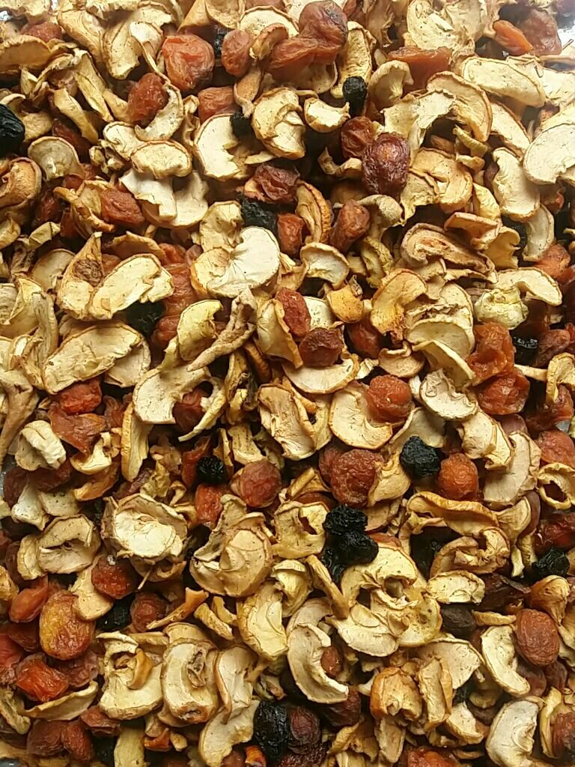
11 | Dry compote mixture  (First grade) | 0.95 | 1,08 | 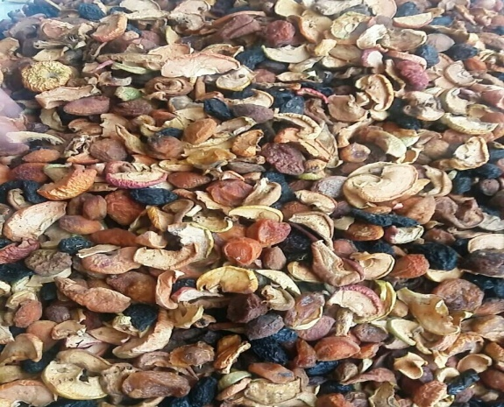
12 | Dry compote mixture  (Class II) | 0,72 | 0,86 | 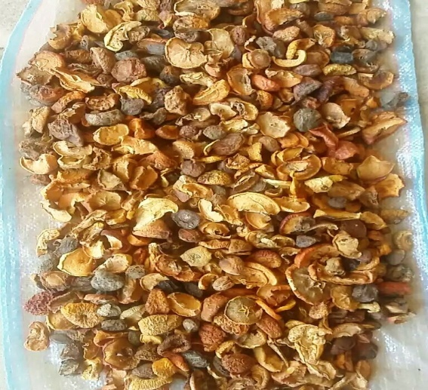
13 | Walnut light  Butterflies Top Grade | 8,01 | 8.15 | 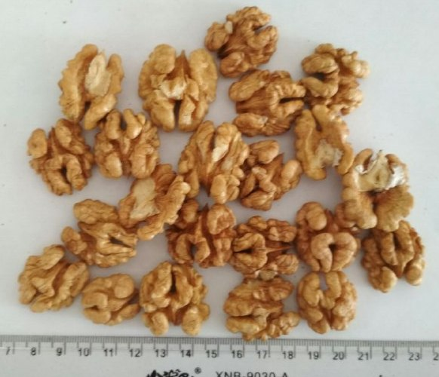
14 | Walnut light  "Butterflies" First grade | 6.98 | 7.11 | 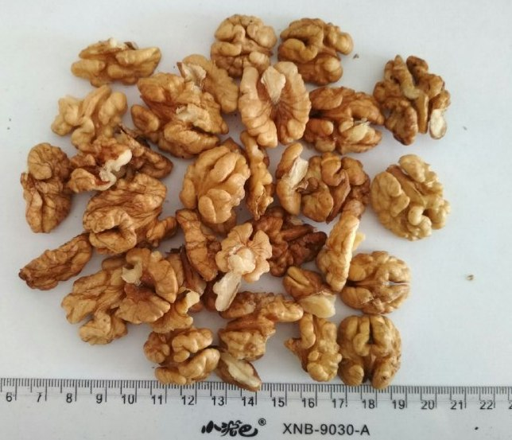
15 | Walnut dark  "Butterflies" First grade | 6,21 | 6.35 | 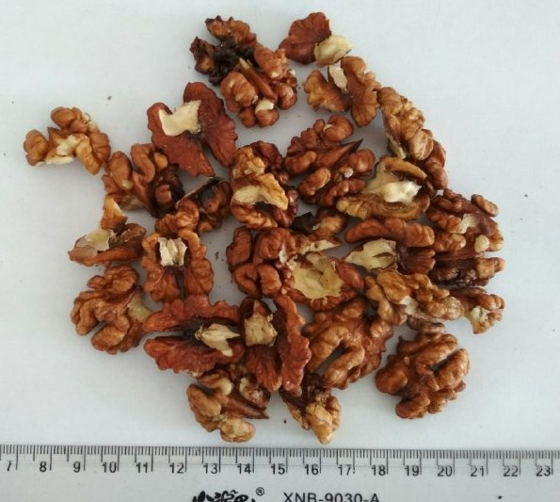
16 | Walnut  Sechki | 4.41 | 4.55 | 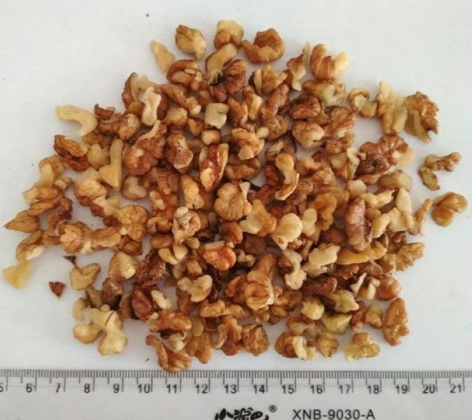
17 | Peanuts peeled | 0.99 | 1,13 | 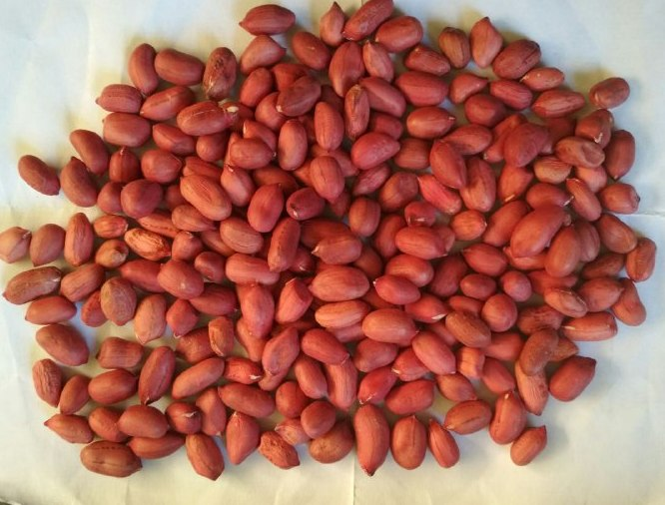
18 | Inshell Peanuts | 0.90 | 1,04 | 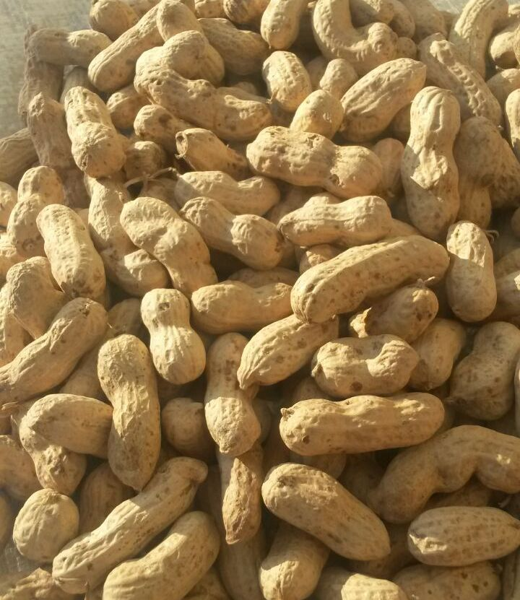
19 | Apricot kernel | 2.93 | 3.06 | 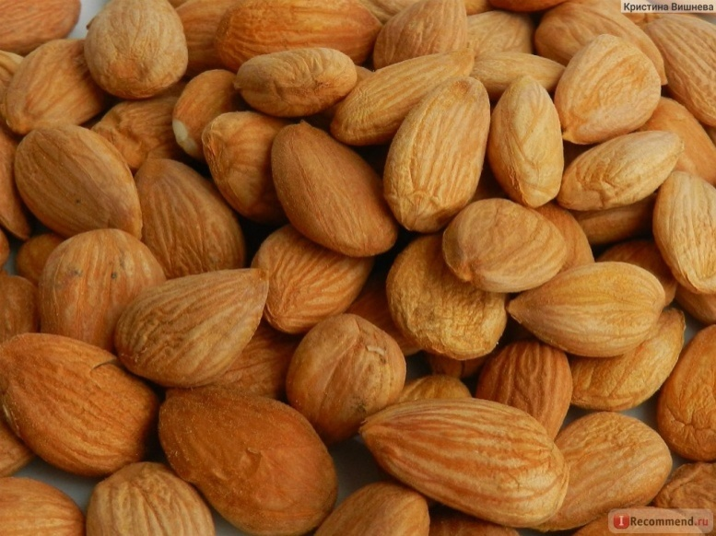
20 | Almond peeled | 6.93 | 7,07 | 